**SQL**

**Database:** Database is an organized collection of structured information or data typically stored in computer system which can be accessed and managed easily.

**DBMS:** Database Management Systems (DBMS) are software systems used to store, retrieve, and run queries on data. A DBMS serves as an interface between an end-user and a database, allowing users to create, read, update, and delete data in the database.

**RDBMS:** The software used to store, manage, query, and retrieve data stored in a relational database is called a relational database management system (RDBMS). The RDBMS provides an interface between users and applications and the database, as well as administrative functions for managing data storage, access, and performance.

**Types of SQL language statements**

SQL Commands

**TCL**

1. Commit
2. Rollback
3. Savepoint
4. Set Transaction

**DCL**

1. Grant
2. Revoke

**DML**

1. Select
2. Insert
3. Update
4. Delete
5. Merge
6. Call
7. Explain plan
8. Look Table

**DDL**

1. Create
2. Alter
3. Drop
4. Truncate
5. Comment
6. Rename

**SQL Practice**

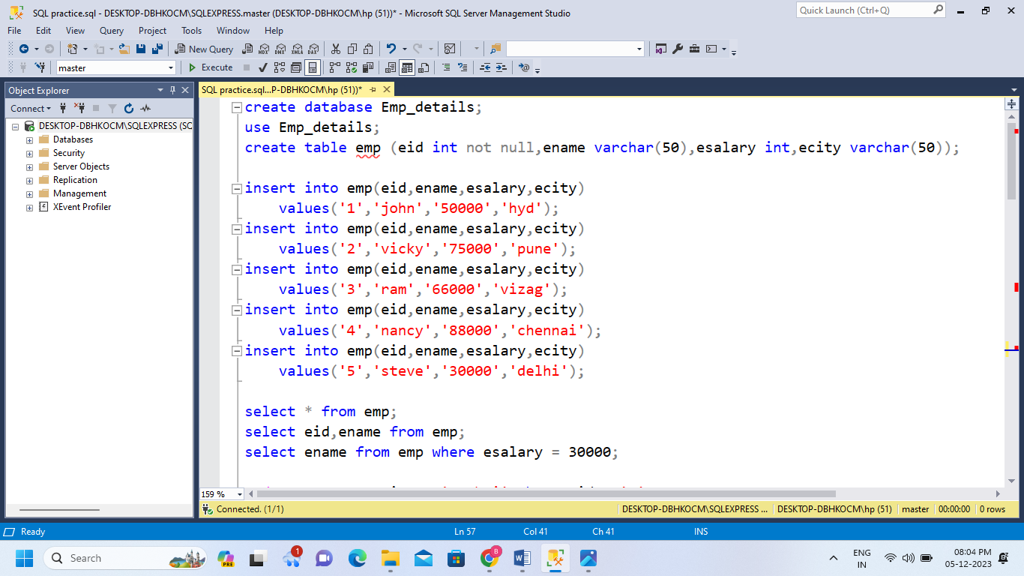

**Database creation:** Details of the employees can be stored in a database by creating the database Emp_details.

* Create database database_name;

**Database usage:** To utilize the Emp_details database we use the **USE** keyword.

* Use database;

**Creating a table:** To enter the details of each employee we need to create the table with column name and its data type.

* Create table table name(col_name 1 data type,cal_name2 data type…);

**Insert command:** Enter the details of each employee by inserting the values of employee by using INSERT command

* Insert into table_name values(“enter the values”);

**Select command:** It fetches the details from all columns of the table or the selected data based on the operations we use.

* Select * from table_name;
* Select col_name from table_name;
* Select col_name from table_name where condition;

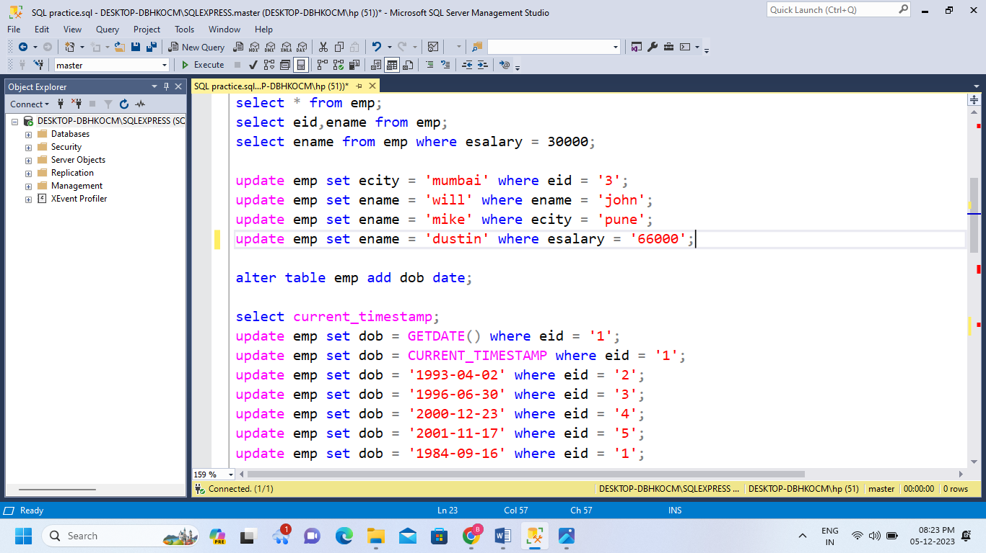

**Update Command:** Updates values in existing table.

* Update table_name set col_name = ‘ ‘ where condition;

**Alter Command:** Modifies the existing data or add new data to the existing table.

* Alter table table_name add col_name datatype;
* Alter table table_name drop column col_name;

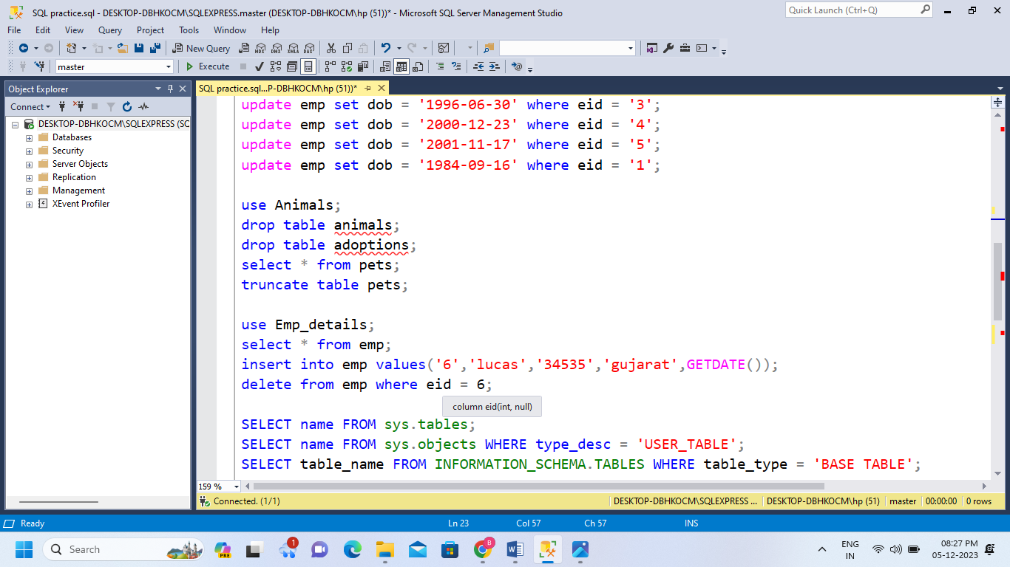

**Drop command:** Deletes whole table and data stored in it.

* Drop table table_name;

**Truncate command:** Deletes all rows in tables but the table structure stays as it is.

* Truncate table table_name;

**Delete Command:** Deletes specific row.

* Delete from table_name where condition;

**Tables details**

* We can get the total table name of the whole databases by using following commands.
* SELECT name FROM sys.tables;
* SELECT name FROM sys.objects WHERE type_desc = 'USER_TABLE';
* SELECT table_name FROM INFORMATION_SCHEMA.TABLES WHERE table_type = 'BASE TABLE';